Security

Defence in depth::

Defence-in-depth is a security risk management approach that uses multiple layers of security controls to protect information. The goal is to prevent unauthorized access to data. If one layer is breached, the next layer can prevent further exposure.

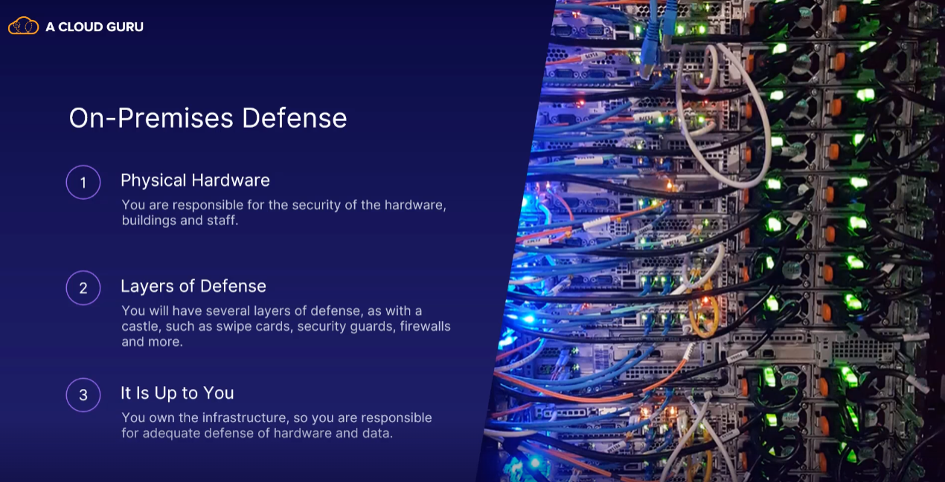

There are Seven general layers of security in cloud computing.

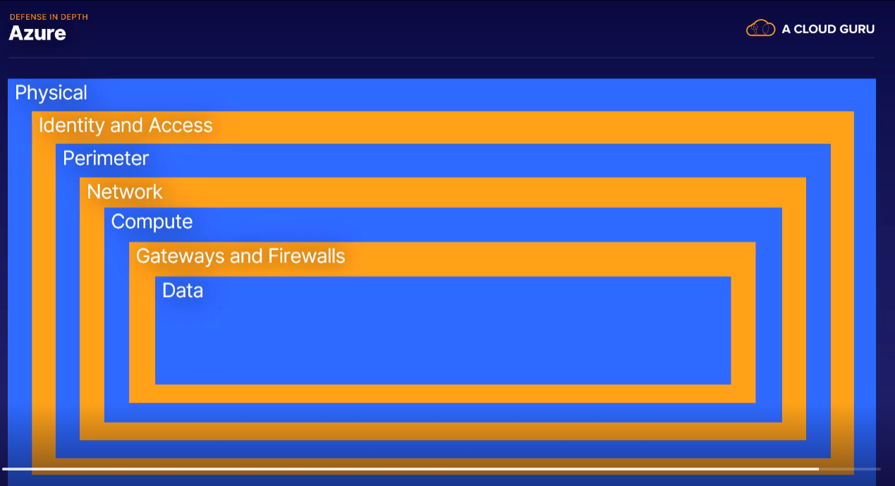

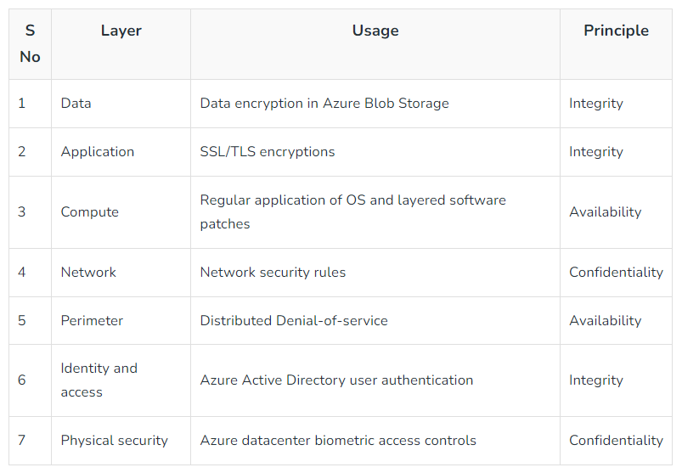

Securing Network Connectivity::

The networks on Azure is what gives access to everything. All your services on Azure are connected to a network in order to communicate with users, processors, and other Azure services. Which means we need to secure that network connectivity.

Firewall

* It is a set of rules that decides whether network traffic is allowed to access the service or device attached to the network.
* Firewalls come in many versions and sizes.

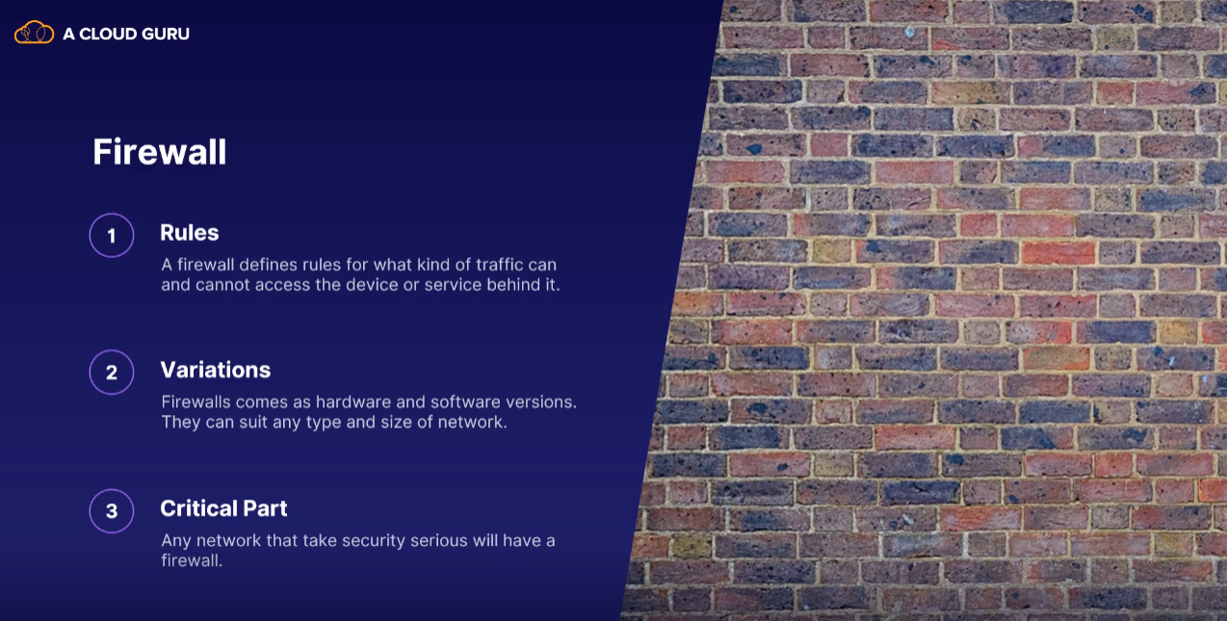

Distributed Denial-of-service Attacks::

* So, distributed denial of service. This is one of the most common attacks on services attached to the internet.
* So a DDoS attack is lots of computers targeting a single server or website with the aim of making it stop.
* Azure DDoS Protection is a service that protects Azure resources in a virtual network from DDoS attacks.
* To protect against DDoS, Azure has the DDoS Protection service.

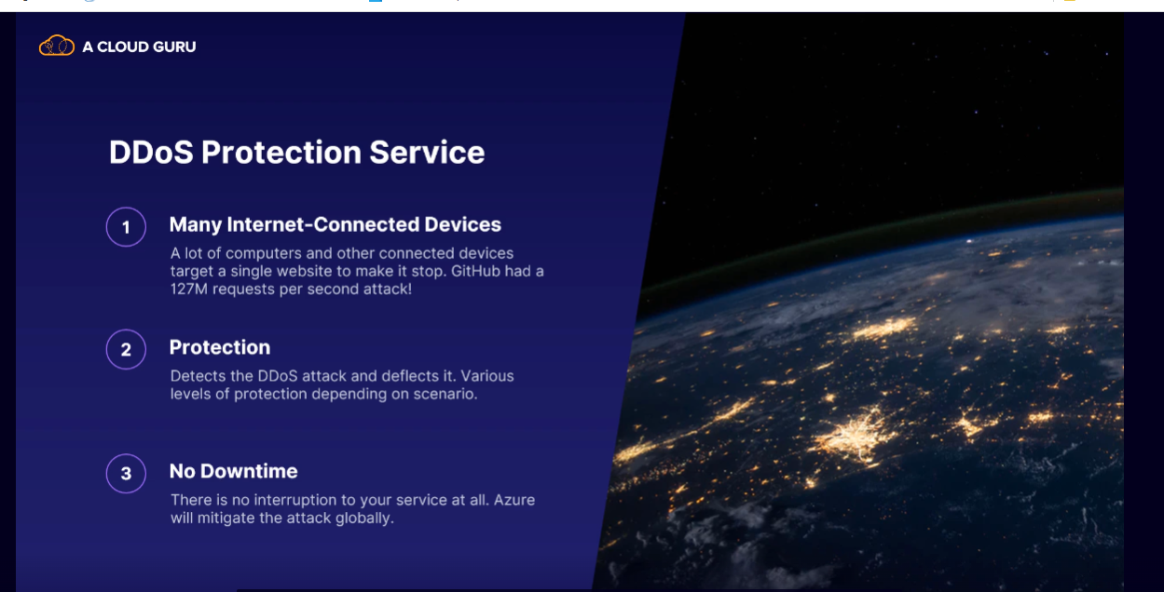

Network Security Groups (NSG)::

\*\* Think of NSG as personal firewalls for your resources.

\*\* You can attach an NSG to any virtual network, subnet, or network interface which is attached to a virtual machine

\*\* A network security group, often called NSG, is a set of rules for who and what can access any resource attached to the NSG.

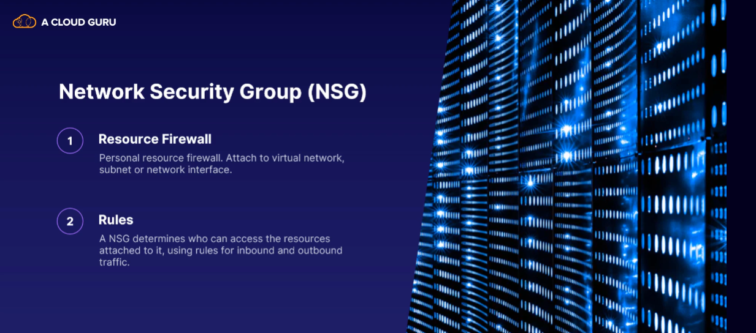

For example, if you have a virtual machine that is on a virtual network, the network can be behind a firewall protecting everything on the network, and then the VM can have its own network security group to define specific rules for just that machine.

So everything is behind a firewall, but the VM has an extra layer of security, which is its own network security group.

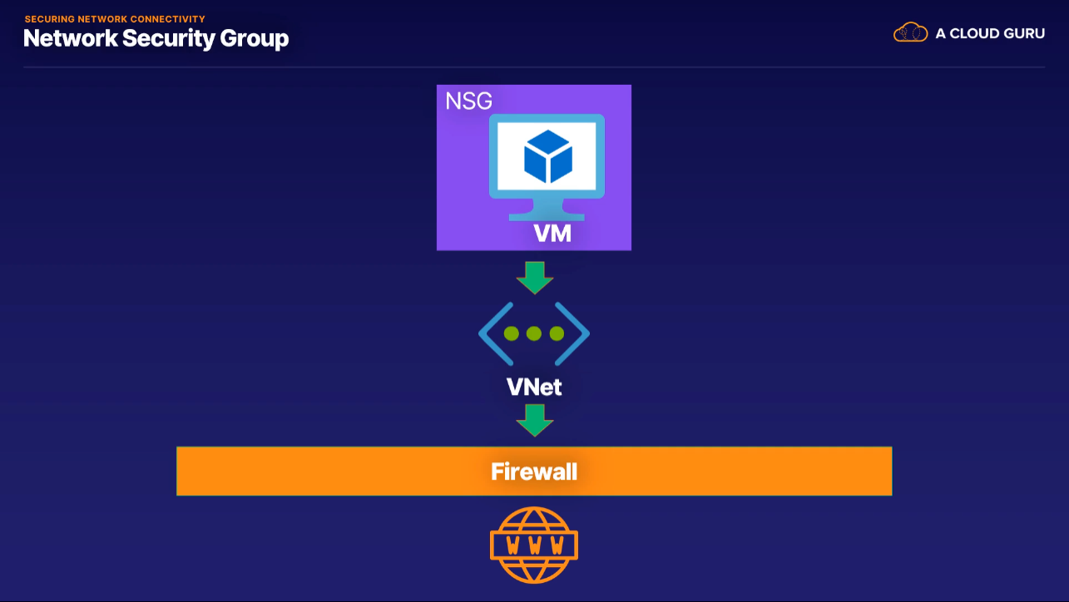

Application Security Groups:::

Application security groups let you configure your network security as a natural extension of an application's structure.

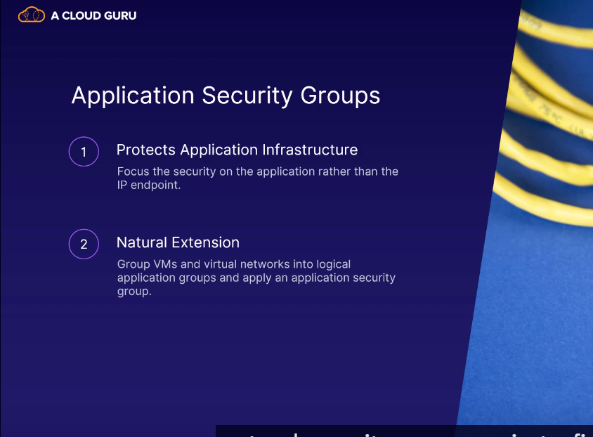

Public and Private endpoints

when you create public services, such as Azure Storage, Azure SQL, and others, these services are publicly reachable or publicly exposed over the public internet.

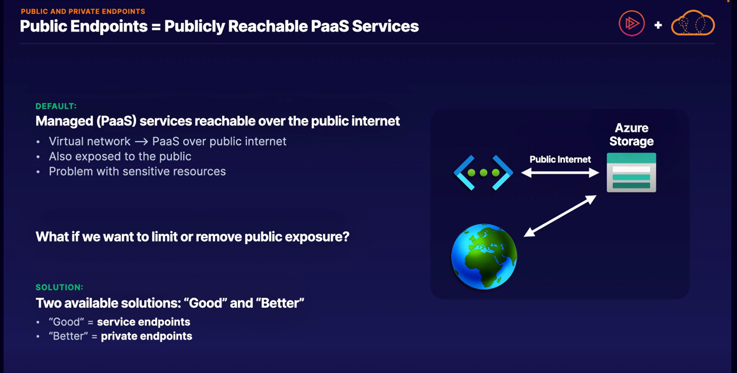

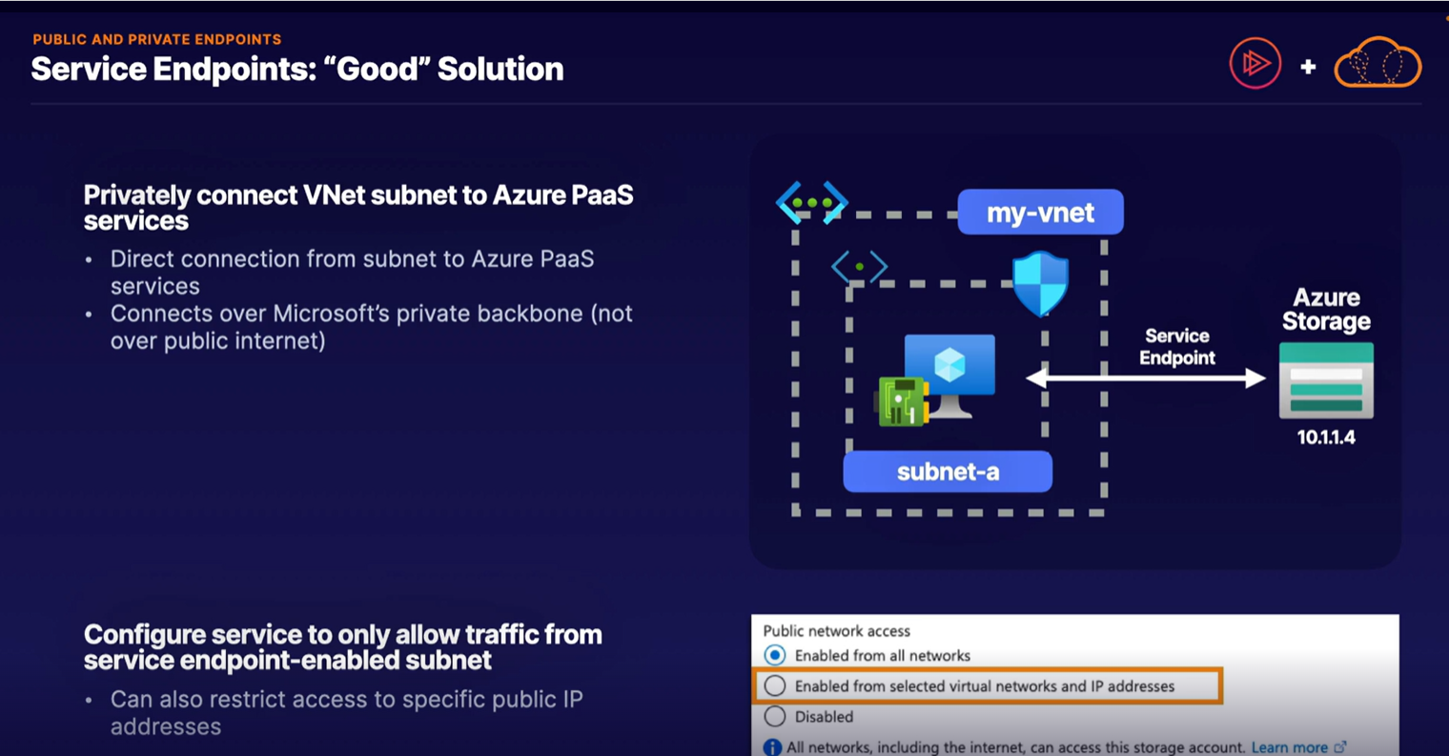

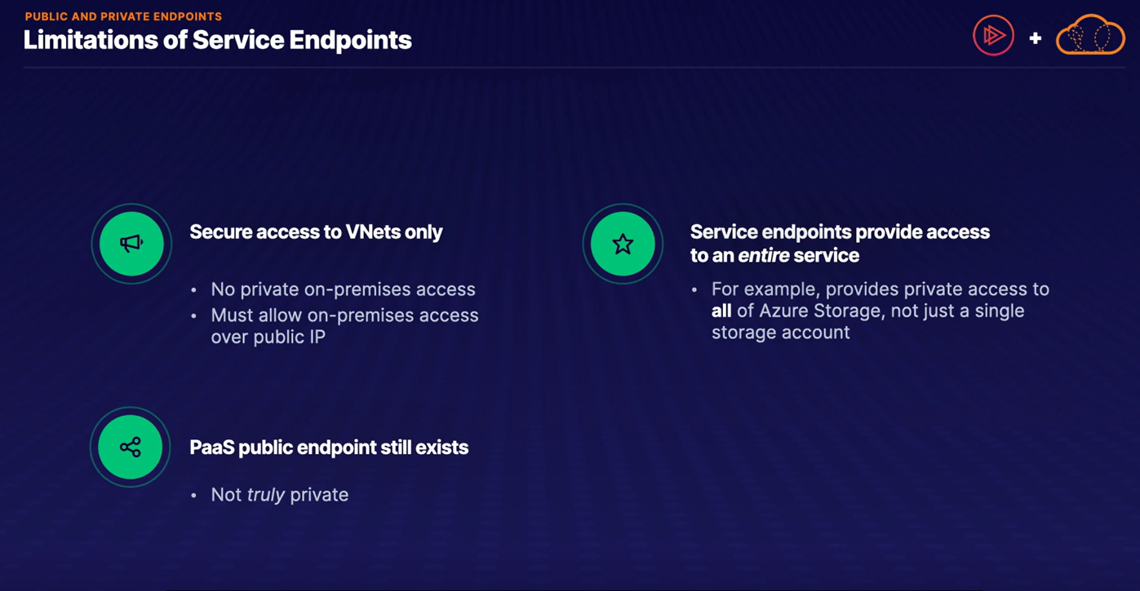

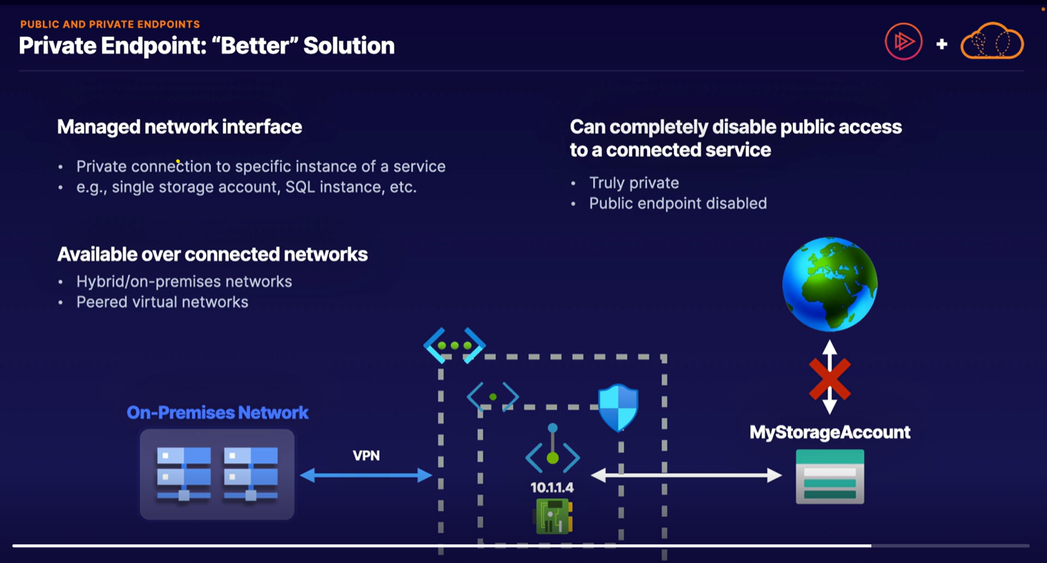

public endpoints in Azure allow resources to be accessible from the public internet, while private endpoints facilitate private, secure communication within Azure networks or with trusted partners.

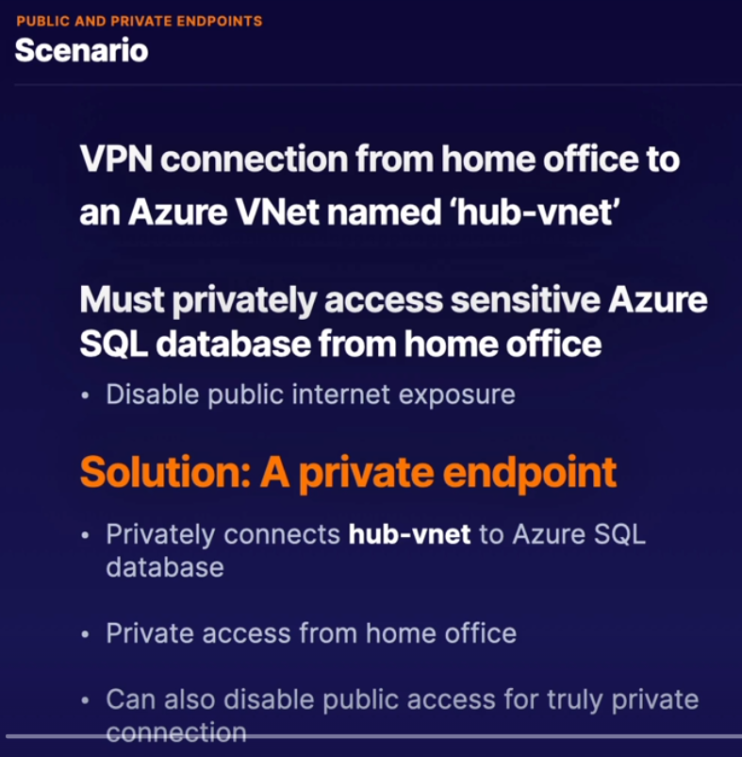

Defender for cloud::

If you are looking for a simple to understand, one-stop shop for viewing and managing all the various security features on Azure, then Microsoft Defender for Cloud, formerly known as Azure Security Center.

* Defender for cloud has it’s own portal in azure portal.
* It provides threat alerts.
* It will also work or hybrid setup.
* This works by each virtual machine having an installed agent that sends data back to the Defender for Cloud.
* Azure analyze the data and send alerts to you if necessary

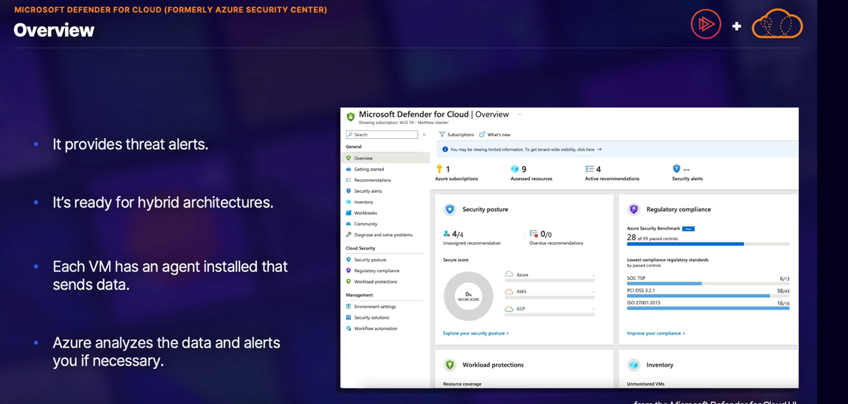

Highlights

* Policy and compliance are monitored by Azure, and the result is shown in the security portal.
* You can be assigned a secure score, to make your Azure implementation as secure as possible.
* You can also get security information from other cloud providers like AWS and Google Cloud platform.
* If any of your virtual machines don't get updated with the latest security and system updates, store encrypted data, or have unnecessary public-facing endpoints and much more, you will get adequate alerts to fix all of them.

Steps for using Defender for Cloud:::

* define security policies

A security policy is a set of rules that Azure can use to evaluate if your configuration of a service is valid. Keep in mind that Defender for Cloud does come with some pre-defined policies by default, but you also have the option to create your own.

* actively protect your resources

While Defender for cloud limits your exposure to threats, you still have to actively monitor the policies and take action on those outcomes.

* if a security incident does occur, well, you have to respond to it.

Security alerts will be raised by Defender for Cloud, and you'll have to triage them. From there, you can then investigate any of the alerts and adjust your Azure implementation accordingly.

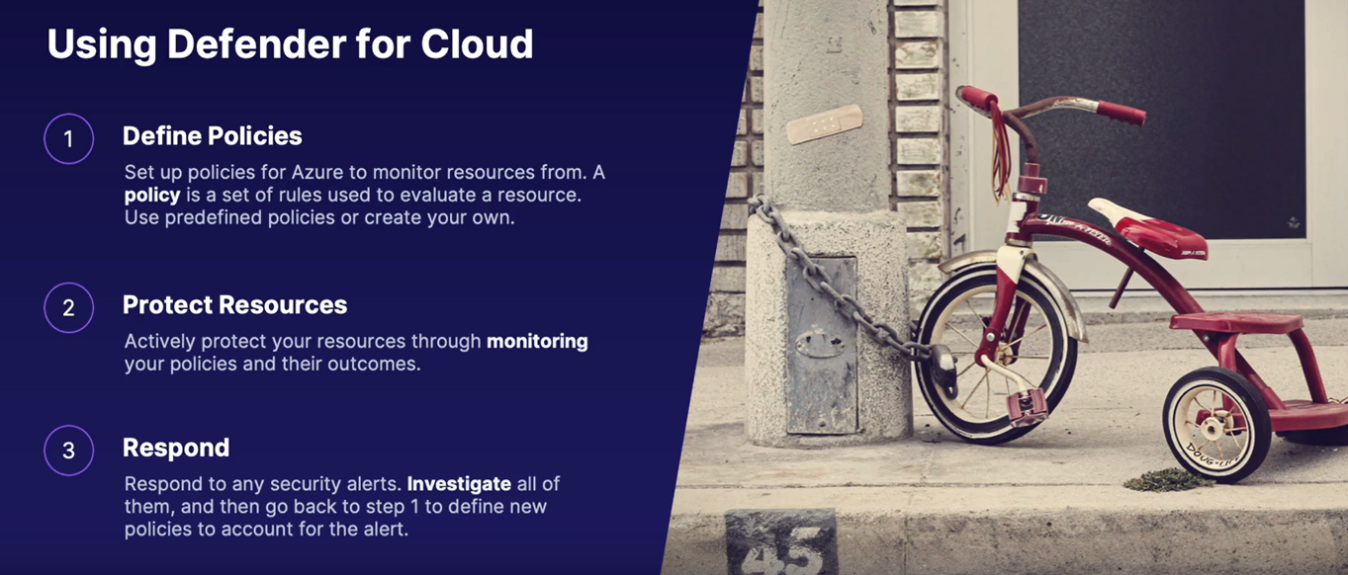

Key Vault::

Azure Key Vault is a secure place to store passwords and other secrets.

You can then share those secrets with others without revealing the actual secret.

Let's say you have a database with some valuable business data in it. While you use the data successfully internally, you also want to share access to other trusted outside third parties. However, you don't want to just give them the username and password to access the database. Instead, you place the password in Azure Key Vault and then provide access to individual applications. The application can identify itself, and then Azure Key Vault grants access to the database.

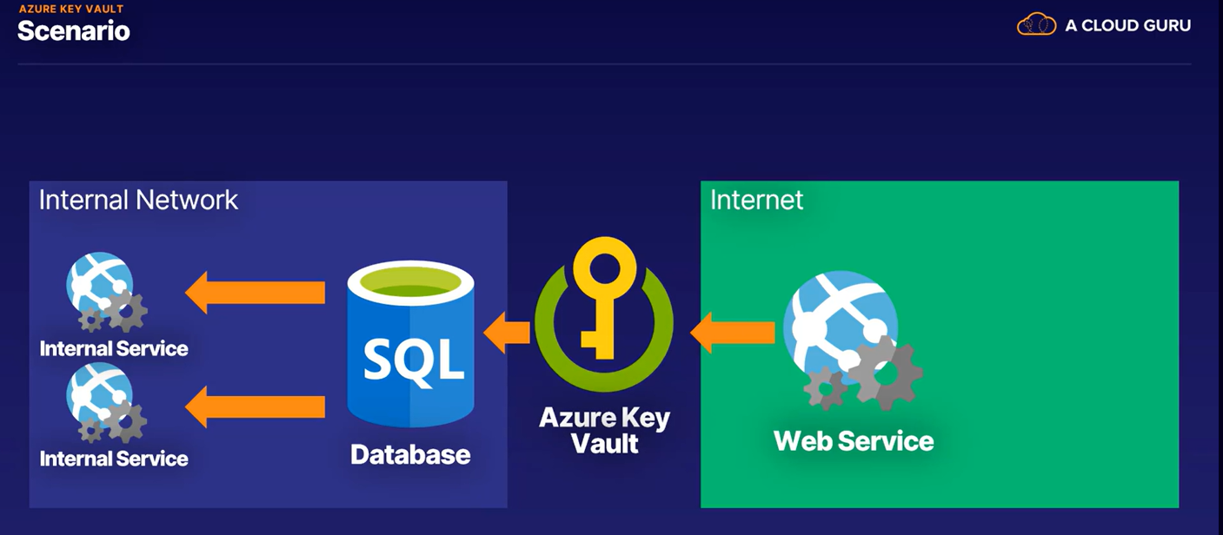

Features::

1. Even if someone could get access to the key vault on Azure, the storage is done on hardware that is secure as well. Not even Microsoft can see or extract your keys in the vault.
2. The application can't pass on the access to any other application, and access can be removed very fast in Azure Key Vault without having to change passwords.
3. Key Vault can scale globally, like any other managed Azure service, so you can get cryptographic high performance too. Next, we go from password protection to protection of email, documents, and other data.

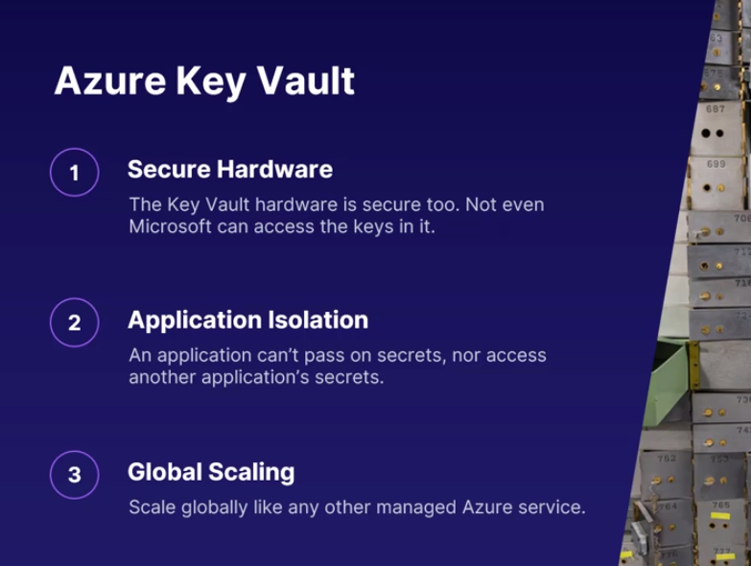

Azure Information Protection::

When data is stored on company servers and resources, how do you really know who has access to your data? What if an employee has gone rogue and has taken the data? Competitors will most likely want your information, but how do you prevent that?

>>>> In order to help companies secure their data, regardless of where it is stored, Azure has the Information Protection Service, which works in conjunction with Office 365, Microsoft's online productivity suite.

1. Classifying data
2. Tracking activities
3. Sharing data
4. Integration

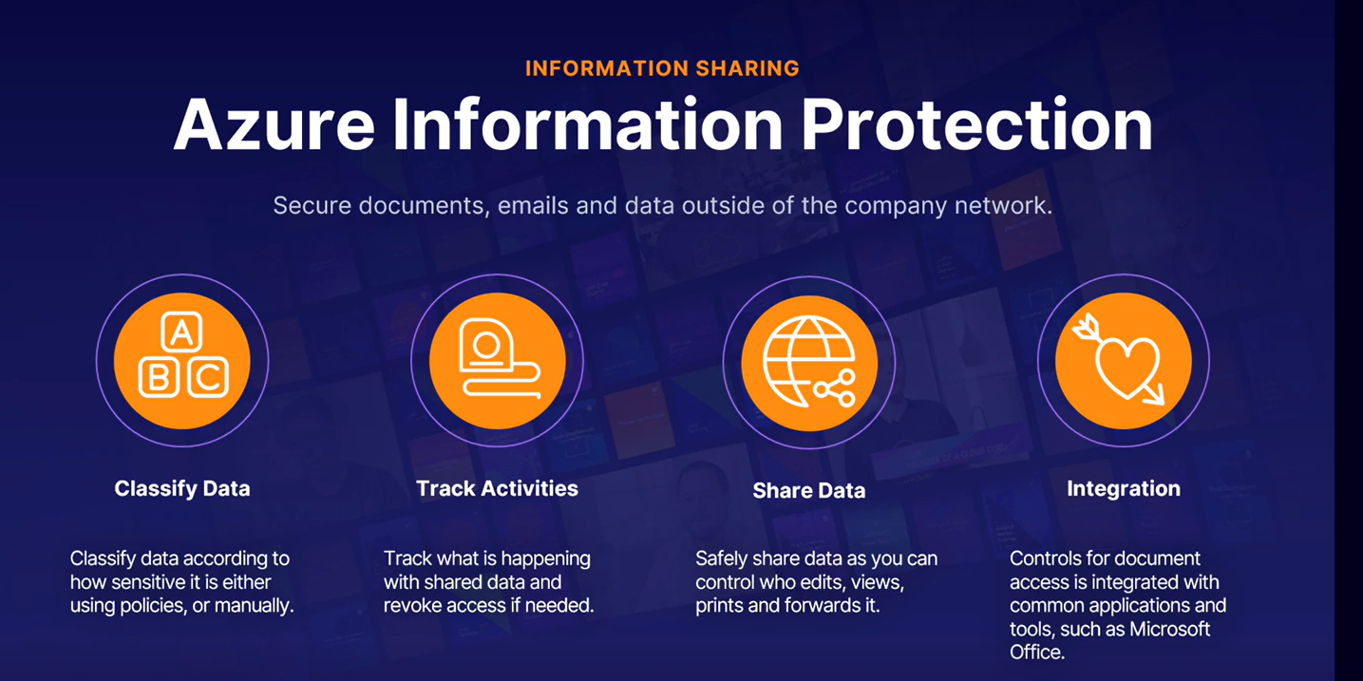

if Melanie has to send an email with a sensitive attachment to Tony, then she can Azure Information Protection to secure that attachment. Melanie uses a label that is defined in Azure to tag the document and create a link to Information Protection. Every time a user opens it, the user is validated and the document is protected.

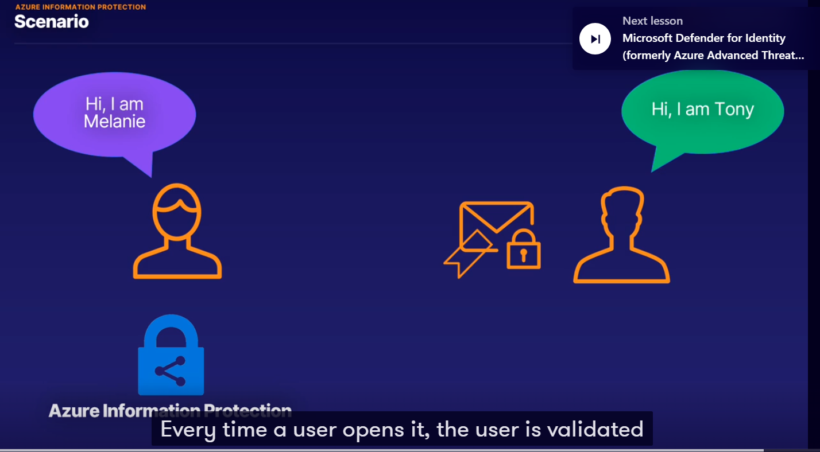

Microsoft Defender for Identity::

The problem is that users are well, unreliable, whether they are internal employees or customers. And if these users have access to your organization's servers, documents, and other systems, then there might be a weak link for attackers.

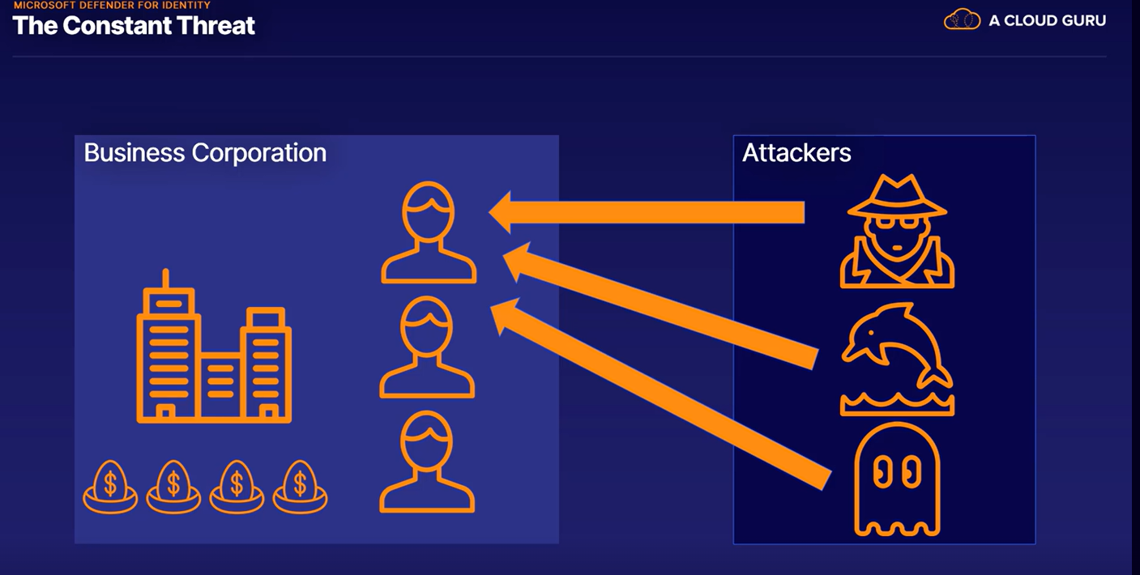

* Microsoft Defender for Identity will monitor the users.
* It will record the normal baseline behaviour, in future if any suspicious behaviour is observed it will log it as a suspicious activity.
* Microsoft Defender for Identity also suggest the changes to provide best security.

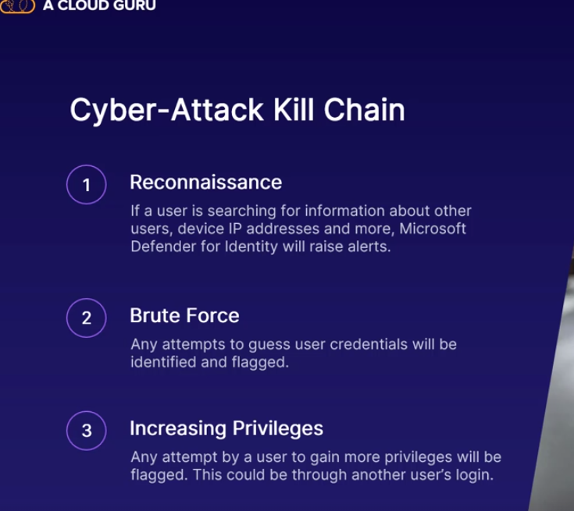

Azure Sentinel::

Sentinel is a security information and event management tool, often just called SIEM.

SIEM works like this

1. Data collection -- Data is collected from a range of sources, such as your network controllers, virtual machines, DNS, traffic managers, and much more.
2. Aggregation and Normalization -- This just means that it's sort of sorted and made a bit more usable.
3. Analysis and threat detection -- data is analyzed and find any threats are detected.
4. Things happen (this part no need to know )
5. Take Action -- any security breaches and threats are identified and you can investigate and take appropriate action.

In other words,

Sentinel will do 90% of the heavy lifting before you even start investigating a potential security alert.

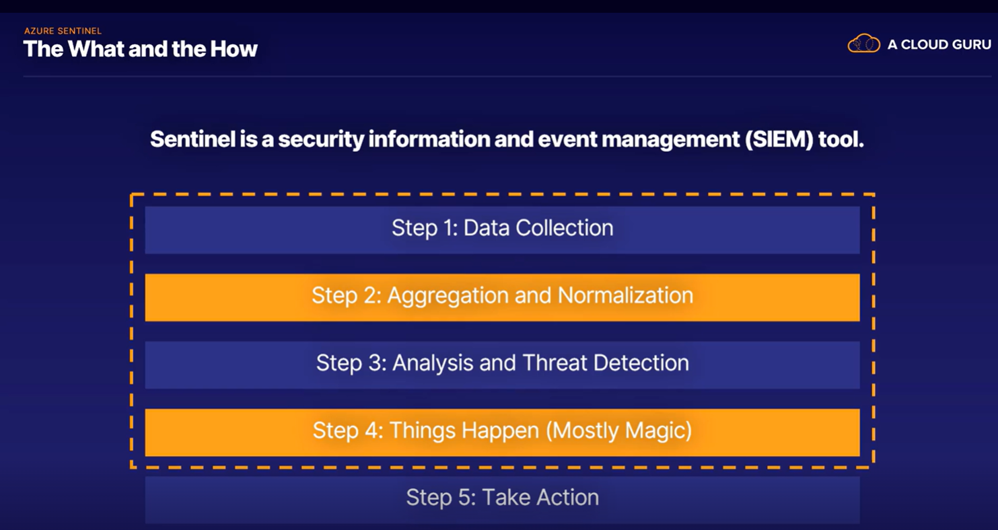

Features

* Behavioral Analytics
* AWS Integration
* Cloud scale
* Large organizations use sentinal

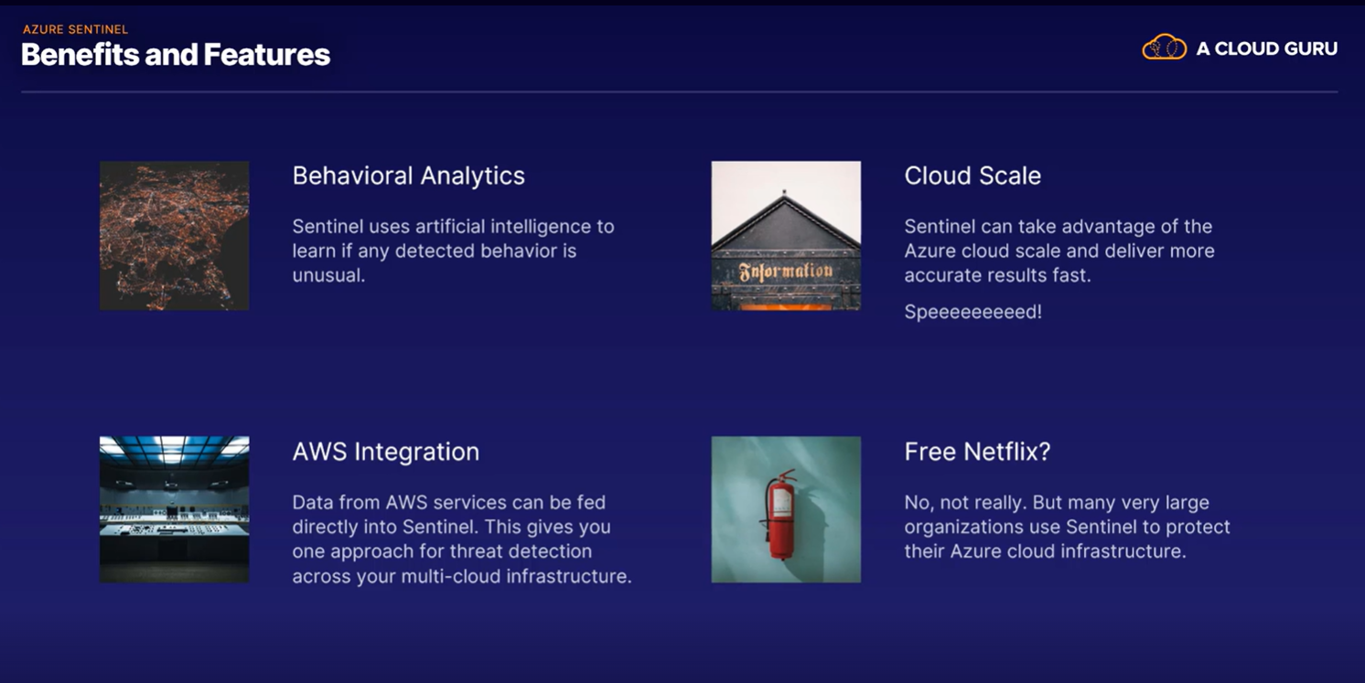

Azure Dedicated Hosts:::

Don't trust the hardware your virtual machines run on? Well, that's what Azure Dedicated Hosts are for.

* Azure Dedicated Hosts is a full physical server that you get full control over.
* The hardware isolation is at the physical layer, so no one else can sneak onto your server. No other VMs will be placed on the hardware, unless they're ones you choose and you create.
* Maintenance
* you can meet more stringent compliance requirements when you're in charge of the hardware.
* You can still take advantage of cloud computing benefits, like availability zones, fault isolation, high availability, and scale sets.
* you can still use Windows, Linux, or SQL Server as your VM image.

